A Block for All

Year 8

Home Learning will be given on insight. Please complete and lace in the sections provided.
Highlight your target: Write in your own words what your understanding.
___________________________________________________________________________________________________________________________________________________________________________________________________________________________________________________________________________________________________________________________________________________________________________________________________________________________________________________
Year 8 DEC
DESIGN TECHNOLOGY Assessment FOR Learning Grid
Assessment Task: Design Development
The Threshold Target for this Assessment. Highlight your target.
EMERGING | Have you stated who you are designing for?
 | Have you made a list of the contents in your classroom?
 | Have you drawn a plan of a block showing different rooms?
DEVELOPING | Have you explained who you are designing for?
 | Have you stated how your classroom is for all?
 | Have you drawn your plan with a ruler and included most symbols?
SECURING | Have you described the demographic of your design?
 | Have you explained how your classroom is designed for all?
 | Have you drawn your plan with a ruler including symbols and measurements for most contents?
EXCELLING | Have you justified the demographic for your design?
 | Have you validated your reasons for the contents in your classrooms?
 | Have you drawn your plan to scale including all symbols and measurements?
EXCELLING + | Have you justified the demographic for your design?
 | Have you validated your reasons for the contents in your classrooms?
 | Have you drawn your plan to scale including all symbols, measurements and links to spatial awareness
Lounge
Kitchen
WC
Hall and Stairs
Could you design a set of classrooms (Block) for everyone? Design
Your challenge is to design a block that is safe, comfortable, accessible and secure, that truly supports health and well-being; a class that is conducive to learning.

Re-write the challenge in your own words:

I am asked to ________________________________________________________________________________________________________________________________________________________________________________________________________________________________________________________________________________________________________________________________________________________________________________________________

Think about the range of people who live in your community, those who live on your street and in your town.
You’ll find the very young and very old, those who are fit and those who are not, those who are disabled, those who are not and a whole range of people who face different challenges in their everyday lives.
Complete a mind map describing what we mean by ALL in the brief.
Quick Quiz:
What do these symbols mean on a plan of a building?
__________
__________
__________
__________
__________
__________
__________
__________
__________
__________
List the items you would want in your classroom. Describe how these items would match the brief.
________________________________________________________________________________________________________________________________________________________________________________________________________________________________________________________________________________________________________________________________________________________________________________________________________________________________________________________________________________________________________________________________________________________________________________________________________________________________________________________________________________________________________________________________
Your challenge is to design a classroom that is safe, comfortable, accessible and secure, that truly supports health and well-being; a class that is truly a class.
You are required to produce:
1. Floor Plans for the classroom
2. Site Plan showing the grounds
3. A 3D Model

HOME LEARNING

Spatial Allocation
Write the definition of Spatial Allocation: ____________________________________________________________________________________________________________________________________________________________________________

Below are examples of spatial allocation.
Task: Create three different drawing showing where you would place the items you discussed on page 4.

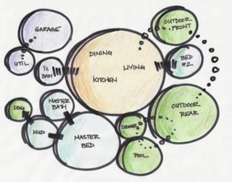
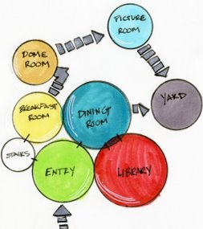
Design 1

Design 2

Design 3
Summary: Which design will you choose and why? ________________________________________________________________________________________________________________________________________________________________________________________________________________________________________________________________________________________________________________________________________________________________________________________________________________________________________________________________________________________________________________________________________________________________________________________________________________________________________________________________________________________________________________________________________________________________________________________________

HOME LEARNING

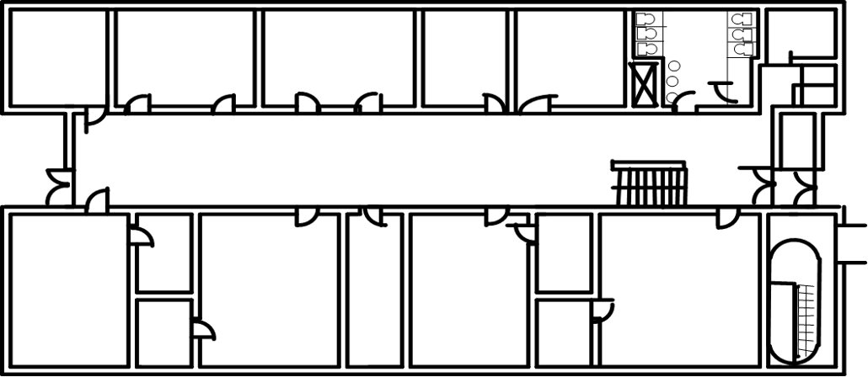
Take note of the following and redraw:
Wall Thickness
Swing door
Double glazed winder
Table
Stool
Cupboard

This is the plan of the Technology Block.
Redraw the Technology Block here.

Draft 1: Complete a plan first draft of your block.
Draft 1 Review:
Peer Marking | Yes | No
Wall Thickness
Door Symbol
Window Symbol
All sections highlighted
Drawing is neat

HOME LEARNING

Draft 2: Improve this draft based on the assessment of draft 1
Draft 2 Review:
Peer Marking | Yes | No
Wall Thickness
Door Symbol
Window Symbol
All sections highlighted
Drawing is neat

HOME LEARNING

Drawing of my Classroom for all.

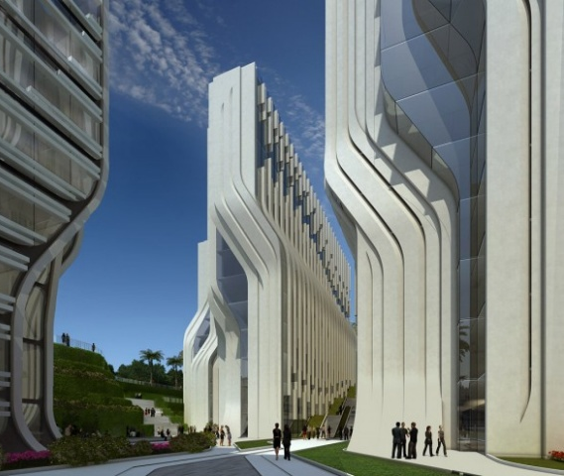
ZAHA HADID Born in 1950 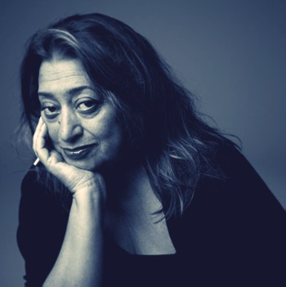

This page is nominated to Zaha Hadid. It can be filled with pictures, facts, thoughts around the work of this famous Architect.

What would the outside of your classroom look like? Use Zaha Hadid as a theme and create four different designs of your classroom for all. Describe how your designs match the work of Zaha Hadid.

Zaha Hadid inspired classroom.

HOME LEARNING

Writing Frame Draft 1
Year 8 DEC

Introduction | Who are you designing for?
What challenges do they face? | What are your solutions?
How is your design inclusive? | Conclusion

Writing Frame Draft 2
Please write it in paragraphs

________________________________________________________________________________________________________________________________________________________________________________________________________________________________________________________________________________________________________________________________________________________________________________________________________________________________________________________________________________________________________________________________________________________________________________________________________________________________________________________________________________________________________________________________________________________________________________________________________________________________________________________________________________________________________________________________________________________________________________________________________________________________________________________________________________________________________________________________________________________________________________________________________________________________________________________________________________________________________________________________________________________________________________________________________________________________________________________________________________________________________________________________________________________________________________________________________________________________________________________________________________________________________________________________________________________________________________________________________________________________________________________________________________________________________________________________________________________________________________________________________________________________________________________________________________________________________________________________________________________________________________________________________________________________________________________________________________________________________________________________________________________________________________________________________________________________________________________________________________________________________________________________________________________________________________________________________________________________________________________________________________________________________________________________________________________________________________________________________________________________________________________________________________________________________________________________________________________________________________________________________________________________________________________________________________________________________________________________________________________________________________________________________________________________________________________________________________________________________________________________________________________________________________________________________________

Name: DT Group: 7
/ 20

Answer all questions on both sides.
1. It takes many different people to design and construct a building. What is the name of the person who ensures the design is safe and meets all the legal requirements?
A. Civil Engineer
B. Model maker
C. Interior Designer

1a. What is the name of the lowest part of a building structure?
A. Foundations
B. Blue Print
C. Exterior

1c What is the correct definition of an Architect?
A. A Brick Layer
B. A person who designs the building
C. A person who pays for the design of the building 3 Marks
2. How many symbols can you identify ? 7 marks
Under each picture, write the full name of each symbol below.

Year 8 Design Technology Exam 2020- DEC

Total marks ….……../ 20
You have been asked to draw a plan that should meet the following requirements.
A) Must fit a land area of 30m²
B) One master bed room with bathroom
C) Dining Room
D) Kitchen
Anything else included will be optional. You are asked to draw a plan including measurements and all
required symbols showing how you will meet this brief.

